Name _______________________________ Date ___________________
Forensic Paint Crossword Puzzle

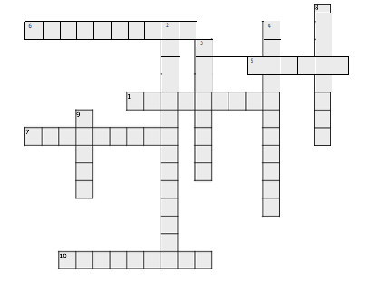
Across:

1. Unpigmented paint layer; adds gloss and durability

- Paint is composed of pigments and a _____

- The most important instrument for comparing paint chips

- When a paint sample is heated to high temperatures until it transforms into a gas

- Most common type of crime where paint analysis is utilized

Down:
- Paint layer; hides imperfections

- Absorbed by binders to yield a spectrum that is unique to a certain specimen

- Examiner matches number and sequence of

colors
- Paint layer; actual color of a vehicle

- The most distinctive forensic characteristic of paint

