Name:_______________________________________________ Date:_________________________________

Forensic Use of Light Fill-in-the-Blank Venn Diagram

Directions: Compare and contrast the two theories of light.
Wave Theory Particle Theory
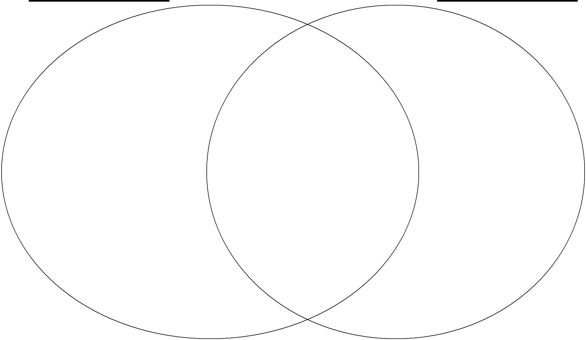

Light acts like a _________. Light transfers or carries Light acts like a ________.
_________.

Light waves are called _____________ waves. Light travels in a __________. Light particles are called ________.

___________ is the distance from the crest of Color of light has to do with the _________ Photons transfer their energy to

one wave to the next. of the wave or the electron. _________.

The entire range of known light waves is We see light that is _______ not absorbed. Energized electrons jump up one ______

called the ___________ spectrum. and then move back down to their
_______ of light is the bending of light. original _______ level.
The ________ of light is 3.0 X 10⁸ m/s.

Some light is ____________to the human eye
As wavelength ______, wave frequency (like ___violet, ___red, & ___rays)

decreases; they are inversely related. but is used in the analysis of
evidence for forensics.

When the electron moves back down, this releases a certain ________ that is individual for every ______ and can be used to identify _________elements.

Other examples of waves are: ______ and water. Light properties are used in many

forms of light technology like
The speed of light wave formula is _____________ The photon theory of light is also
wave speed = __________ x ___________. _____________ known as ________ physics.
and _____________

Forensic Use of Light Fill-in-the-Blank Venn Diagram Key

Directions: Compare and contrast the two theories of light.

Wave Theory Particle Theory
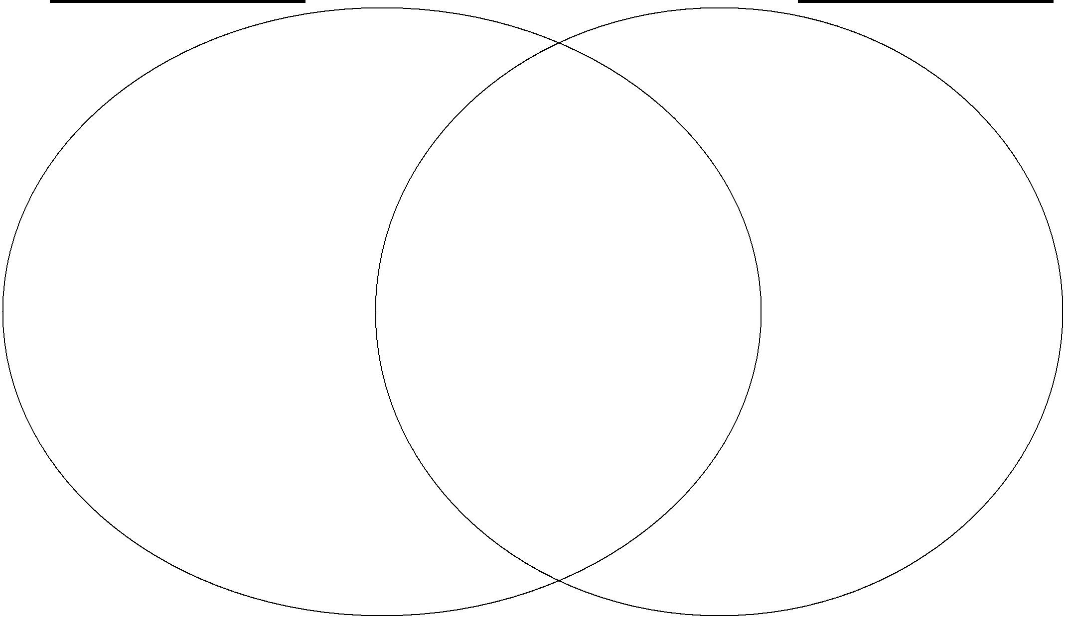

Light acts like a wave. |  |  | Light transfers or carries |  | Light acts like a particle.
 |  |  | energy

Light waves are called electromagnetic waves. Light travels in a vacuum.

Light particles are called photons.

Wavelength is the distance from the crest of one wave to the next.

The entire range of known light waves is called the electromagnetic spectrum.

The speed of light is 3.0 X 10⁸ m/s.

As wavelength increases, wave frequency decreases; they are inversely related.

Color of light has to do with the frequency of the wave or the electron.

We see light that is reflected not absorbed.

Refraction of light is the bending of light.

Some light is invisible to the human eye (like ultraviolet, infrared, & X-rays) but is used in analysis of evidence for forensics

Photons transfer their energy to electrons.

Energized electrons jump up one energy and then move back down to their original energy level.

When the electron moves back down this releases an certain color that

is individual for every element and can be used to identify unknown elements.

Other examples of waves are: sound and water. |  |  |  |  |  |  | Light properties are used in many
 |  |  |  |  |  |  | forms of light technology like
The speed of light wave formula is |  |  |  |  |  |  |  | microscopes, spectrophotometry,
wave speed = wavelength x frequency. |  |  |  |  |  |  |  |  | refractometers, and lasers.
 |  |  |  |  |  |  |  |  | (answers may vary)

The photon theory of light is also known as quantum physics.

