Forms & Data Acquisition Lab Exercise 1

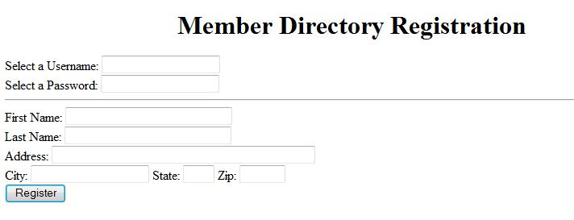
For this lab you will create the form shown below. The form will be submitted to a processing script to verify the proper transmission of information.

Open your text editor and setup the basic HTML tags.
- Below the opening body tag, open a form tag.

- Below the opening form tag, add a hidden field. The name should be labcode and the value should be 3287.

- The request for a Username should be a text field named user.
- The request for a Password should be a password field named pass.

- Below the request for a username and password, add a horizontal rule <hr />

- The remaining fields, with the exception of the button, should all be text fields. Assign each field the following names and sizes:

Form Field |  | Size | Field Name
First Name | 30 |  | fname
Last Name | 30 |  | lname
Address | 50 |  | address
City | 20 |  | city
State | 2 |  | state
Zip | 5 |  | zip

Be sure you layout the form fields as shown with all fields on a separate line, except for the City, State, and Zip which should all be on the same line.
- The button should be a submit button with a value of Register.

- Make sure you have included the closing form tag below the submit button.
- Resave the document and preview it in your browser.

- Enter data into the browser and submit it. The processing script should display each of your field names with the data entered into the field

