Forms & Data Acquisition Lab Exercise 2

For this lab you will create the form shown below. The form will be submitted to a processing script to verify the proper transmission of information.
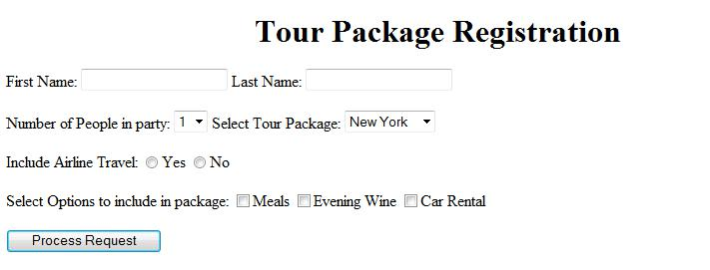

- Open your text editor and setup the basic HTML tags.

- Below the body tag, add the text “Tour Package Registration” as a centered level 1 heading.

- Below the opening body tag, open a form tag. The method should be post.

- Below the opening form tag, add a hidden field. The name should be labcode and the value should be 3287.

- The name for the first name field should be named first and the name for the last name field should be last.

- Both the fields should be on the same line as shown in the example. After the last name field add two line breaks.

- The Number of People in party should be entered with a select field. The visitor should have the option to select from 1 to 4 people in their party. The value and label for each option should be 1, 2, 3, and 4 consecutively.

- The Select Tour Package should give the visitor the options to select from New York, Hollywood, Orlando, and Nashville. The options and values should both be the city names.

- Add two line breaks after the Tour Package select menu.
- The visitor should select whether to include air travel with a radio button. The radio button group should be called airline. The value for Yes field should be yes and the value for the No field should be no.

- After the radio buttons set add two line breaks.

- The checkboxes should give the visitor the option to add Meals, Evening Wine, or Car Rental. The name of each field should be meals, wine, and car consecutively.

- After the checkboxes add two line breaks.

- Add a submit button with a value of Process Request.

- Make sure you have a closing form tag after the submit button.

- Resave the document and preview it in your browser.

- Enter data into the browser and submit it. The processing script should display each of your field names with the data entered into the field

