Name: _________________________________________________ Date: ______________
Fruit of the Poisonous Tree Doctrine Worksheet

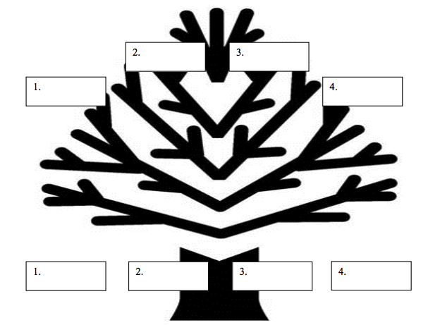
Write the primary evidence (the tree) and the secondary evidence (the fruit) from each of the following scenarios:
- An officer stops a minor that is driving a red vehicle. The only reason for the stop is because the officer dislikes red cars. The officer sees a marijuana pipe still lit on the middle console. The officer searches the vehicle and finds illegal weapons in the trunk.
- The officer in above case (#1) requests that a search warrant be issued for the home of the driver. The magistrate issues a warrant because he does not know that the above stop was illegal. The officer proceeds to search the driver’s home and finds stolen electronic equipment in the garage.
- An officer has an invalid search warrant. The officer proceeds to Saturn Cleaners and searches the premises. The officer seizes documents, which include a map with directions and a designated spot. The officer follows the map and discovers a dead body at the designated spot.
- An officer answering a noise ordinance violation (barking dog), knocks on the door, but no one answers. The officer hears the barking dog and pries open the door. The officer locates the source of the noise and realizes that it is only a computer making the sounds. The officer takes the computer as evidence. Upon inspection of the computer, the officer finds financial records of illegal drug transactions.

