The Global Economy

Student Notes

Fill in the blanks as we discuss the multimedia presentation. Keep this as a study guide.

TERMINOLOGY:

- ________: North American Free Trade Agreement

- ______: World Trade Organization

- _____: European Union

- International Trade: The _____ of products/services to people in _______ countries

- Imports: Products/services _______________ from another _____________

- Exports: Products/services _______ to _____________ country

- Indirect Exporting: Marketers with ______________ experience __________ the

____________ company; ____________ for the _________ of products in other countries
- Direct Exporting: Company handles ____ responsibilities to market products in other

___________

- Balance of Trade: The ________________ between a country’s _________ and

__________

- Foreign Production: A company ______ and __________ production ___________ in another country

- Joint Venture: ____ or_____ companies in ____________ countries with

_____________ interests develop a _______________ to join in ____________

__________________activities.

- Multinational Companies: Businesses that have_________________ all over the

___________ and conduct planning for _________________ markets

- Pre-industrial Economy: Based on _________________ and ______

_____________development; _____ standard of living

- Post-industrial Economy: Based on____ of business and consumer

_____________________ produced and marketed in the__________ marketplace

- Gross Domestic Product: The ________ $ value of all ______________________

produced within a country in____ year

- Gross National Product: The total___________ of all goods/services (_____________

_____________) produced within a country in one year

- Quota: _________ on the numbers of ___________ _________ of products

____________ _________________ can ______ in a country

- Tariffs: _________ placed on imported products to increase the ____________

__________
- Subsidy: ___________ provided to a business to _______ in the development and sale of products

- Standard of Living: A ______________ of the quality of life for the citizens of a country

- Software as a Service (SaaS): Distribution model where users utilize ___________________ made available over a ___________________ such as the ________________________________, instead of the traditional method of installing the software on their _______________________________ machine. Users typically pay a __________________________ fee for using the software for a period of time
- Productivity: The____________ output by workers for a ______________ period of time

- Purchasing Power: The ___________ of goods/services that can be bought with a

______________ $ amount of money
- Consumer Price Index: The _____________ in the ________ of a specified set of goods over _______

- ____________ _________: Consists of 4 stages: Prosperity, Recession, Depression and Inflation

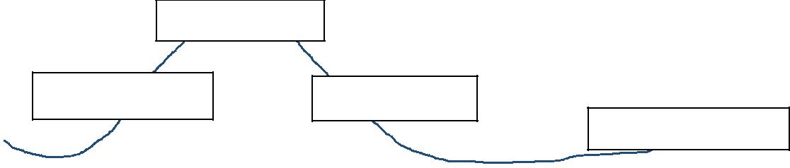
• |  |  | : Describes the process for planning,
creating, testing, and deploying software systems.

U.S. and International Trade

World Interdependence

•”Approximately _____ of world-wide production is sold _________ of the

_______ country.”

•U.S. __________music, movies, software, and IT services among many other things.
International Trade is Changing

• |  |  |  |  | once were an abundant commodity; today
 | makes up less than |  | of world’s exports.
• |  |  |  | goods/services are most popular.

•_____________ (communications, travel, education, and financial) are the most popular exchanges between _______________.

•_______ is transferred via phone, fiber optics, or satellite on a daily basis.

οNew software services such as |  |  |  |  |  |  |  | and
are creating new |  |  | business models.
°SaaS is |  |  |  |  | changing the face of international software

marketing due to this fact.
Businesses are Going Global

•_____________ are changing.

•____________ markets are enticing to ________________ businesses who experience dropping sales and profit.

•Foreign markets are another way to expand ________________and increase

worldwide ___________for products and |  |  |  |  |  |  |  |  |  | .
ο |  |  |  | is replacing standard |  |  |  |  |  |  | due to
 | availability of |  |  |  |  | devices and low-cost apps.
ο | World leader in software |  |  |  |  |  |  |  | is located in US and obtains
 |  | of its revenue from SaaS.

•Benefits of international marketing

o | Government support is |  |  |  |  | .
 | °Companies are |  |  |  |  | to developing software in the US due to
 | strong enforcement of
o | Software and IT Services Industry |  |  |  |  |  | annual |  |  |  | by an

average of 6% in 2011 with a projected growth of almost 17% over the next two _____________ accounts for more than ___________ of _________________________________________
Importance of International Trade

- U.S. economy: over ___________ businesses _________ products.

- Accounts for over _____ of GNP.

- _____ of U.S. exporting businesses are small to medium sized.

- As of 2011_____________of the top 100__________________vendors are based in the

- Manufactured ________ over $500 billion of products.

- Wholesalers export over $____ billion worth of products.

- U.S. is __________ largest exporter.
- U.S. is home to____________of the world’s largest___________________companies.
- _____________ is #1 exporter.

- U.S. is #1 ___________ of products.
.
- Germany is _____ importer.

- _____ had 1st_________ deficit of the 20th Century in ______ (imports exceeded exports
by over $1 billion that year).

