Group Progress Rubric

Name: _____________________ Teacher: ___________________

Date: ______________________ Title of Work: _____________

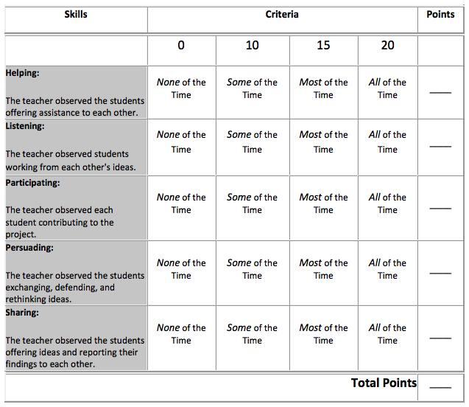

Teacher’s Comments:

