Name_________________________________Class:__________Date:___/___/___

Hand Tools

Lab #2 – Adjust Wire Strippers

Equipment and Materials

- Adjustable wire strippers

- Variety of solid insulated conductors

- Screwdriver or nut driver to fit adjustment screw

Procedure

1. Loosen adjustment screw (Figure 1)
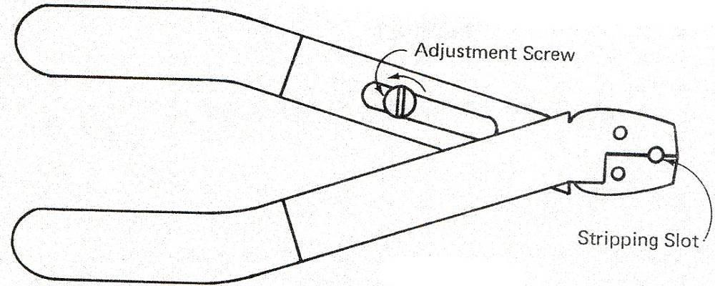

- Insert conductor into stripping slot

- Close jaws until you feel that you have reached the conductor

- Open jaws slightly
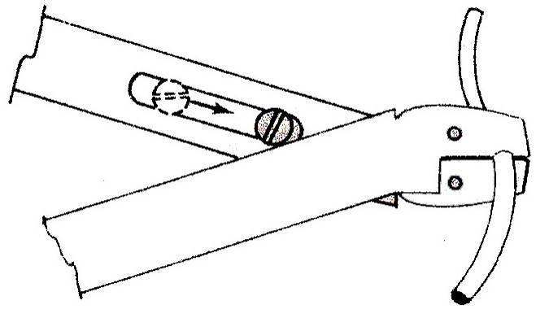

5. Slide adjustment screw down to its setting position (Figure 2)
- Strip off approximately 3/8-inch of insulation

- Check conductor for ring or nick (Figure 3)

Note: If nicks occurred, loosen adjustment screw, readjust, and test again until insulation is removed without conductor damage.

