Name: Date:

History of Fingerprinting Quiz
Part I: Matching
Select the best choice from the right column and write the corresponding letter:

1) | William Herschel |  | a) | recognized the importance of fingerprints as
 |  |  |  | a means of identification
2) |  | Henry Faulds | b) | Started requiring Indians to sign English
 |  |  |  | contracts with fingerprints
3) |  | Francis Galton | c) | Created a searchable fingerprint
 |  |  |  | classification system
4) | Will West |  | d) | Published “Finger Prints” which discussed
 |  |  |  | the anatomy of fingerprints and pattern types
5) |  | Edward Richard Henry | e) | A criminal whose case contributed to the use
 |  |  |  | of the fingerprint system

Part III: Short Answers
Classify the following fingerprints using the 3 pattern types:

6)
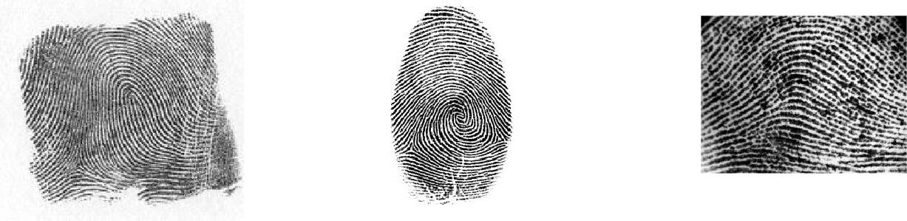

- What is AFIS?

- What city/agency was the first in the U.S. to utilize fingerprints as a means of identification?

