Interview : Development and Conduction of a Survey Rubric
Independent Practice Activity #1
Student Name: _____________________________________________________
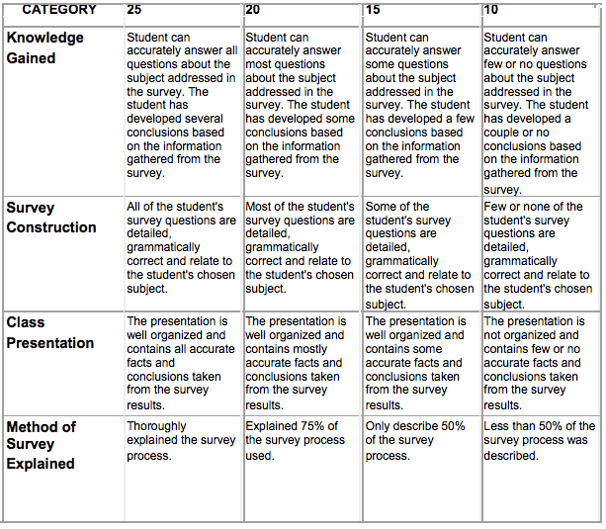
Total Score _________
Maximum 100 Points

