Multimedia Project : Radio Commercial Rubric
Independent Practice Activity #2
Student Name: _____________________________________________________
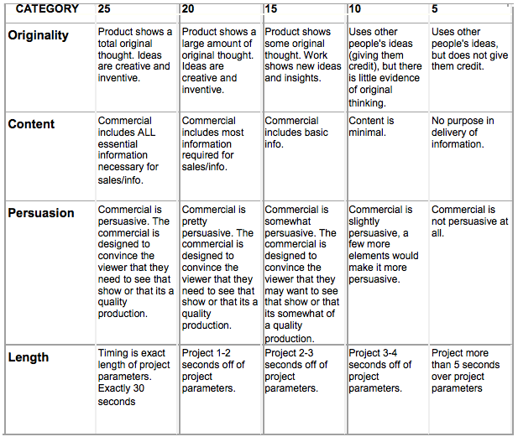
Total Score _________
Maximum 100 Points

