Business Document Formatting
Informal Assessment

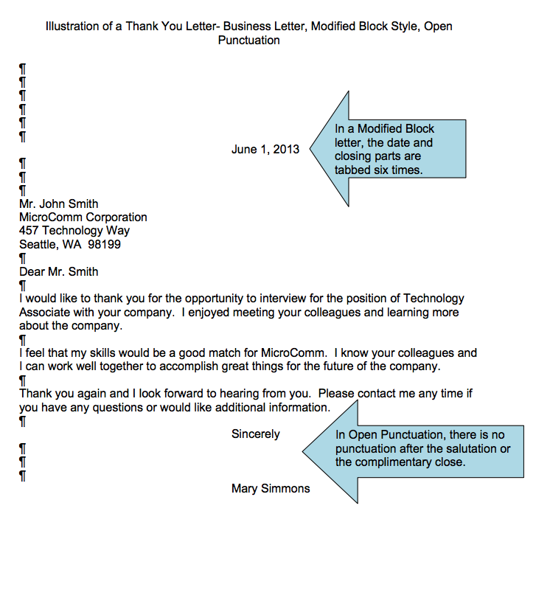

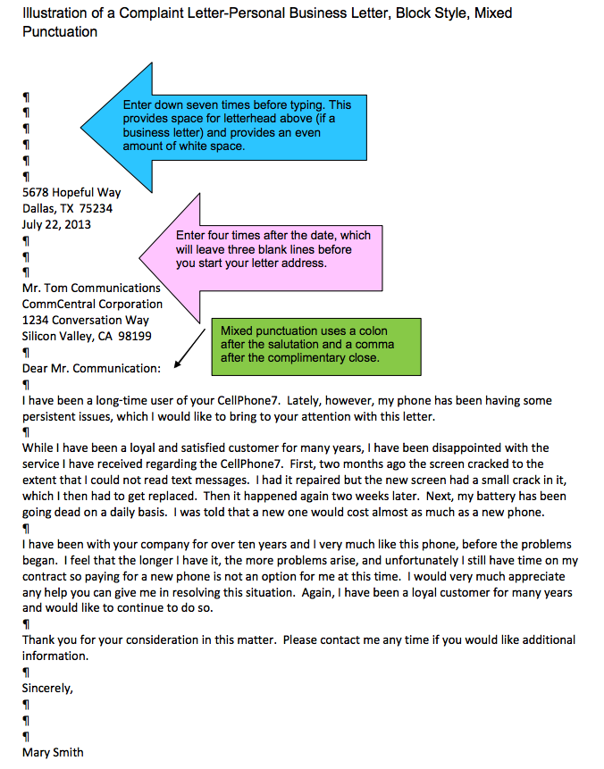

Letter Parts

SPACE
DATE
LETTER ADDRESS
SALUTATION
BODY
BODY
BODY
COMPLIMENTARY CLOSE
LETTER WRITER

