Name: _____________________________________ Date: _____________________

Ink Chromatography Lab

Objective

- To perform chromatography in order to separate ink mixtures into their separate pigments
- To compare known inks to the unknown sample and make a match

Introduction

John Johnson awakes to find his wife missing and a ransom note. Mr. Johnson is the CEO of a financial firm and was recently awarded a big bonus. This isn’t common knowledge, which is why the police officers have narrowed the suspects down to 4 people that work with Mr. Johnson. They need your help to identify the suspect immediately and get Mrs. Johnson back safe and sound. The following is what the ransom note said. You will need to obtain a section of the actual note from your teacher to perform the chromatography.

Mr. Johnson, if you ever want to see your wife alive again you will do the following:

- Withdraw $350,000 from your bank account at the branch on Central Avenue

- Deposit $250,000 into the Cayman Account #456987

- Put the remaining $100,000 in an untraceable briefcase and leave it under the

slide at the playground at Sherlock Elementary on Watson Drive You have until 7pm tomorrow.

Materials

- 4 different black markers
- 5 beakers or cups
- Filter paper (coffee filters, paper towels, or chromatography paper)
- Water
- Scissors
- Pencils
- Ruler
- Strip from the ransom note
- Ink Chromatography Data handout

Procedure

- Measure the height of your beaker or cup. Cut a piece of filter paper about ½-inch wide and ½-inch longer than the height of your beaker or cup (for example, if the beaker is 6 inches tall, then your paper should be 6 ½ inches tall).

- Pour about 10 ml of water into the bottom of your beaker or cup.

- Measure about 1.5 cm up from the bottom of the filter paper and make a line across it in PENCIL. Pick one of the four markers and make a dot with it in the middle of the line. Label the top of the filter paper with the brand of marker in PENCIL. See the example below:

Marker 1

1.5 cm from the bottom

- Lower the filter paper into the beaker or cup with the water. Important: make sure the dot of color is above the water. Only the filter paper below the dot will touch the water. Stand the filter paper up in the beaker or cup and either hang it by pushing a pencil through the top or fold the top over the edge of the beaker or cup to hold it in place.
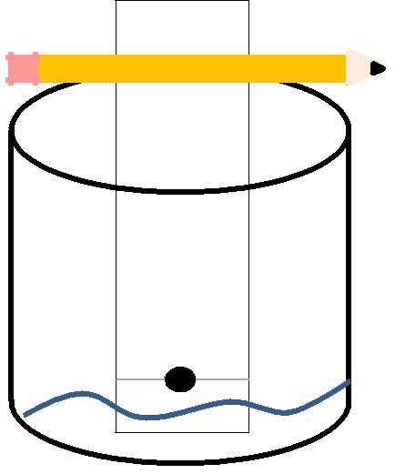

Marker 1

- The water will immediately start moving up the filter paper. Just leave the filter paper there and repeat steps 1 – 4 for the other 3 markers.

- Leave the filter paper in the beaker or cup for 3 – 5 minutes. When you take the paper out immediately make a line in PENCIL at the highest point where the water traveled.

As you are waiting for the filter papers to dry, obtain your strip of the ransom note from your teacher. Place it in a beaker with water like you did with the 4 strips of filter paper. But do not make a dot since there is writing on it already. Try to keep any writing above the water line. Allow it sit in the water about 3 minutes. Then take it out and draw a line across the highest water point as you did with the other strips. While you are waiting for it to dry, complete the Ink Chromatography Data handout.

- Fill out the data and answer the conclusion questions. Attach your filter papers to your Data handout and turn them in when you are finished.

Conclusion

Answer the following after you have finished your data:

- Did any of your markers have the same results? Explain why you think this is.
__________________________________________________________________
__________________________________________________________________
__________________________________________________________________
__________________________________________________________________

- What do you think is the purpose of the water in this experiment?
__________________________________________________________________
__________________________________________________________________
__________________________________________________________________
__________________________________________________________________

- Do you think the chromatography results could be enough evidence alone to convict someone of a crime? Explain your answer.
__________________________________________________________________
__________________________________________________________________
__________________________________________________________________
__________________________________________________________________

- What are some other mixtures that you think you could use a chromatography lab on? Give at least 2 examples.

__________________________________________________________________
__________________________________________________________________
__________________________________________________________________
__________________________________________________________________

- According to your results, which type of marker was used to write the ransom note?
___________________________________________________________________
___________________________________________________________________
___________________________________________________________________

- In about 5 sentences write a summary of what you learned in this lab and how chromatography could be useful in the field of forensic science.

