Key
Introduction to Engineering Fundamentals and Civilization

Match the word or phrase on the left with its definition on the right.

Invention | Limitation or restriction
Constraint | The practical application of science to commerce or industry
Model | A new way of doing something, an improvement on an existing form
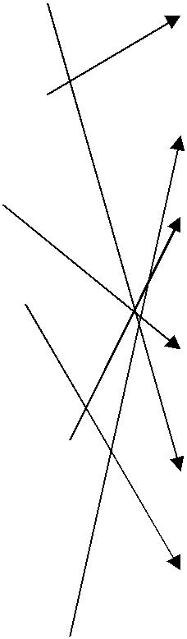  Artifact | A simplified representation of a system or phenomenon, as in the sciences or economics
Innovation | A new, useful process, machine, improvement, etc., that did not exist previously
Technology | An object produced or shaped by human craft

Match the invention or innovation on the left with the time era in which it was produced on the right.

The grinding stone Stone Age
Metalwork Bronze Age
Plague and famine Middle Ages
Forming and shaping Iron Age
The theory of universal gravitation Renaissance
Air conditioning Twentieth century
Domestication of animals Stone Age
Governments Bronze Age
Sailing ships Middle Ages
Division of labor Bronze Age
Mills and foundries Middle Ages
The printing press Renaissance
The steam engine Industrial Revolution

