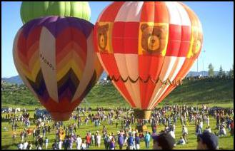
BALLOON RACE GAME

Materials needed:
Small to medium sized balloons, container for questions
TEKS:
Varied, based on the content of the questions
Approximate time:
20 minutes
Directions:

- Prepare questions. Write them on small pieces of paper (or cut them into strips) and place them into a container that you can shake to mix up the questions.
- Divide the class into two teams.

- Select a captain and a “balloon person” for each team. Explain that the balloon person is responsible for blowing up the balloon and needs to put as much air into the balloon as possible with each individual breath.

- Give each team a balloon.

- Each team will take turns alternately answering the questions provided for this game.

- Determine which team will go first (coin toss, guess a number, answer a question, etc.)

- Draw a question out for the first team and read it. The team has 30 seconds to answer the question. All members may participate, but the only answer that is accepted is the one officially given by the team captain.

- If the answer to the question is wrong, nothing happens and play goes to the other team after the teacher gives the correct answer. If the answer to the question is correct, the balloon person puts as much air into the balloon as possible with one breath and play goes to the other team.

- A winner is determined when all questions have been used. The team with the largest balloon is declared the winner. Or, if during play, a team’s balloon breaks from the amount of air put into it, then that team has won the first round of play. Each team is given a new balloon and the 2nd round of play begins. The team that has won the most rounds of play when questions run out is the winner.

- It is OK to have a tie.

