Job 4 Flyer

You will be using a word processing software, generate a flyer to advertise a room that is available for rent. Your flyer needs to include:

- a top banner and a left banner,
- an image,
- a drawing that you will generate using Word, and
- all (fake) information about the apartment.

Here is an example of such a flyer:
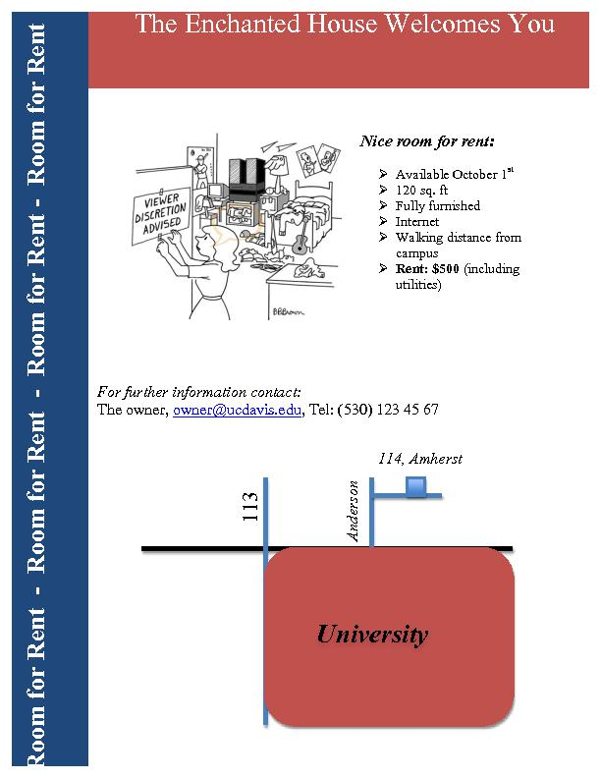

Note that you do not need to repeat exactly the flyer shown above! You are free to use your imagination, as long as the core elements defined above are present.

What makes your flyer appealing?

- Clean, clear, concise, and informational (appropriate fonts, not too many words, enough information, but not all tiny details)
- Visually appealing (look at your layout, bullets are great, but do not include 20 bullets)
- Colorful, but not too colorful

