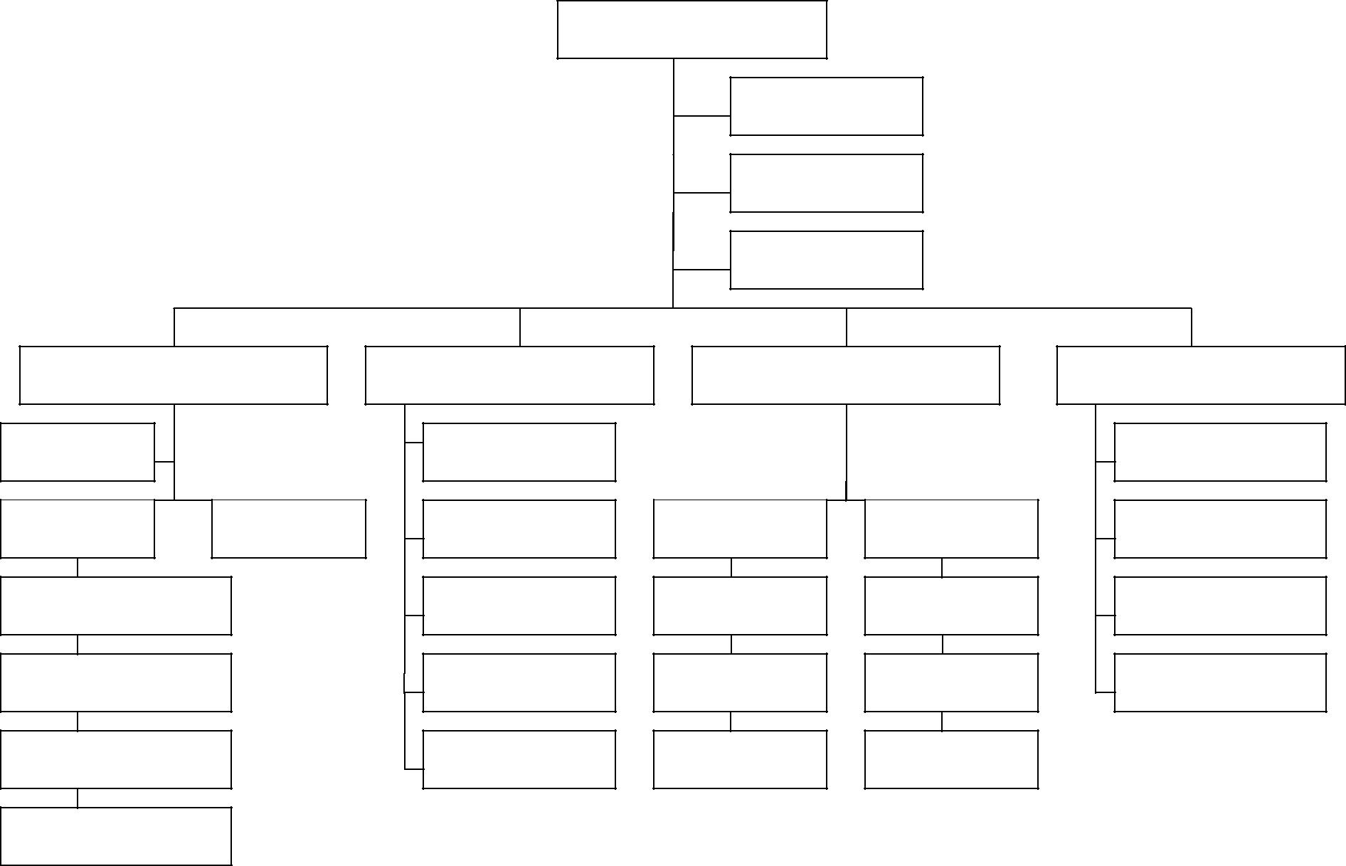
Incident Commander

Safety Officer

Liaison Officer

Operations Chief

Staging

Planning Chief

Resource Unit

Information Officer

Logistics Chief

Finance Chief

Time Unit

Branch Branch

Divisions/Groups

Strike Team

Task Force

Single Resource

Situation Unit

Demobilization

Unit

Documentation

Unit

Technical

Specialist

Service Branch

Communication
Unit

Medical Unit

Food Unit

Support Branch

Supply Unit

Facilities Unit

Ground Support
Unit

Procurement Unit

Compensation/Claims

Unit

Cost Unit

Incident Command

System Model Key

