Keyboards, Mice, & Other Input Devices – Word Search
Locate each of the words in the word search below. You should become familiar with each of the terms. The words can go forward, backward, up, down, or diagonal. During the Keyboards, Mouse, & Input Devices lesson, pay attention to learn the meaning of each of these words.

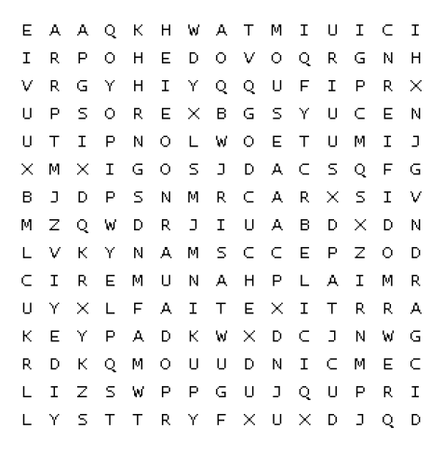
- Keyboard
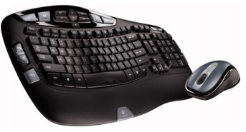
- Mouse
- Input
- Alphanumeric
- Cursor
- Modifier
- Function
- Keypad
- Ergonomic
- Drag

