Name: ____________________________________ Class: ________ Date ___/___/___

Sources of Electrical Energy

Lab #2 – Generate Electricity with Magnetism

Equipment and Materials

- Magnet (preferably a bar magnet)
- Compass

Note: A galvanometer or voltmeter can be used for the compass.

- 36 inches, approximately, of hook up wire

Procedure

- Wind about four turns of wire around your compass, then loosely wrap the rest of the wire around the bar magnet.

- Wind the wire so that the ends will be close enough to be connected.

Note: The wire forms a continuous loop. See Figure below.
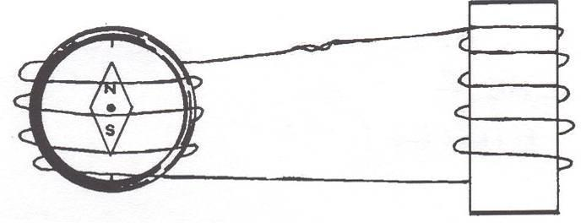

- Move the magnet out of the “coil” of wire, and observe the movement of the compass needle.

- Move the magnet back into the coil, and observe the movement of the compass needle.

- Hold the magnet still, and move the wire coil while observing the compass.

