Name_____________________________________Class:____________________Date:___/___/___

Basic Electronics - DC Magnetism

Lab Activity Handout #1 - Show the existence of magnetic lines of force around a magnet.

I. Equipment and Materials

    - One magnet

    - Compass

    - Flat piece of glass or clear Lucite (approximately 8” X 10”)

    - Shaker of iron filings II.

II. Procedure

    - With a compass at least five yards away from the magnet, see that the needle points to earth’s “north.”

    - Bring the compass to within four inches of one pole of the magnet and observe the change in the compass needle indication.

    - Bring the compass to within four inches of the magnet’s other pole and observe the change in the compass needle indication.

    - Place the magnet under the center of the flat piece of glass.

    - Using the sketch below, move the compass into the positions indicated by number.

    - Record the needle indication at each of the positions.
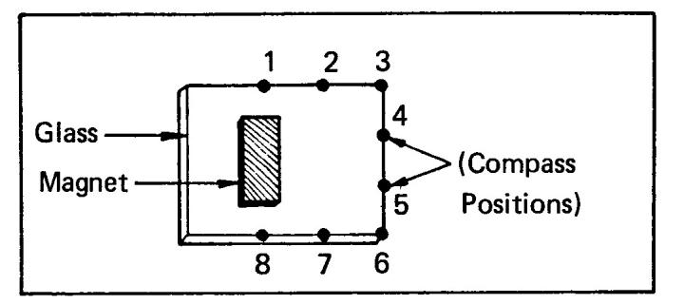

- With the magnet still under the center of the flat piece of glass, sprinkle iron filings on top of the glass.

- Observe the lines of flux indicated by the iron filings.

I. Make a sketch of the pattern formed by the filings

Answer the following questions and hand in for a grade.

- Does the compass indicate that there is a force surrounding your magnet?

- Do the compass indications show the direction of the flux lines? Explain why your compass indicates the flow.

- Do the iron filings concentrate at the poles?

- Why are the lines of flux spread out when not in the vicinity of the poles? Give two reasons.

- Do the lines of flux cross each other?

- Give at least three other characteristics of magnetic fields that are illustrated by the position of the iron filings.

J. Return the materials to their storage area

