Basic Use of a Microscope Lab Key

Important: Always use the lowest objective first. Use the coarse adjustment to focus before the fine adjustment. Once focused on a lower power, it is then okay to use the next higher power and focus before moving on. Be cautious! Never use the coarse adjustment on the highest power—you will see nothing and you could crack the slide by moving the stage too close to the objective lens.

Materials Needed:
  - Compound microscope
  - Glass or beaker of water
  - Variety of prepared slides
  - Eyedropper (plastic disposable is OK)
  - Electricity source (possible with power strips)
  - Newspaper sections
  - Microscope slides and cover slips
  - Small scissors
  - Tweezers

- Label the parts of the microscope.
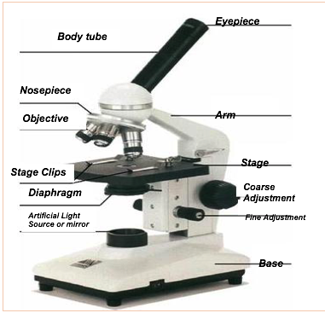
- How do you calculate the power of magnification?
Multiply the power of each objective by 10 (because the eyepiece has 10 times the power). For example, low power is normally 10X, so the total power of magnification would be 100X.

- Calculate the powers of magnification for each objective lens:
- What happens to our view of an image as you increase the power of magnification?
The view will be closer, the image will be more detailed and appear 3-D.

- Why can’t you use the largest objective for some slides?
Some slides will not focus on the largest objective because it is too close the slide will be too close to the objective lens, or because the slide shows an image that is best seen on a lower power.

- Try viewing the prepared slides provided by your teacher. Choose one slide and draw what you see at three different powers of magnification. Label each drawing.

Name of the specimen on the slide: _________________________________

Magnification Levels
Low Power: 100 X Medium Power: 250 X High Power : 650 X

- How do you make a wet-mount slide?
1 – Get a clean slide and cover slip from your teacher.

2 – Place 1-3 drop of water in the middle of the slide. Don’t use too much or the water will run off the edge and make a mess!

3 | – Place the |  | top of the cover slip on one side of the |  |  |  |  |  |  |  | microscope slide .
4 | – Slowly |  | drop |  |  | the cover slip on top of the drop.
5 | – Place the slide on the |  |  |  |  | microscope stage |  |  | and view it first with the lowest objective.
 | Once you see the image, you can rotate the |  |  |  |  |  |  | nosepiece |  |  |  | to view the slide with the
 | different objectives.

- Make a wet mount slide using the letter “e.” Using the newspaper provided, cut out a lower-case letter “e.” Prepare the wet slide as directed. It is very important that you place the letter “e” right-side up, as you would normally read or write the letter.

What is unusual about this image?

Draw what you see at three different powers of magnification. Label each drawing.

Magnification Levels
Low Power: 100 X Medium Power: 250 X High Power : 650 X

