Name________________________________ Date__________________________

Light Diffraction Hair Diameter Lab
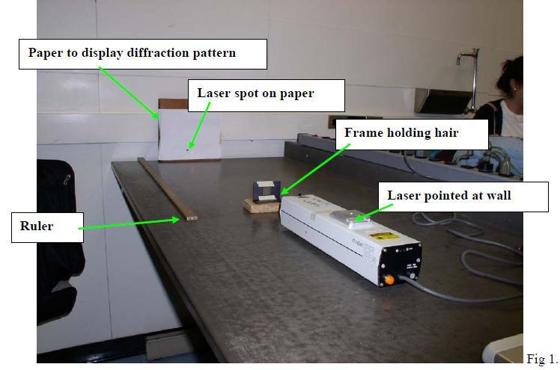

Introduction:

Sometimes in forensics it is necessary to determine the diameter of a hair, fiber, or other object that cannot be measured by conventional means. These items can be measured by using methods of diffraction and interference known as Young’s Double Slit Experiment. While Young’s experiment deals with the pattern of light impinging on two narrows slits separated by a small distance, the method can be applied to an object with a small diameter as well.

Materials:
- Helium-Neon laser (also called He-Ne laser)
- Scotch or transparent tape
- Scissors
- Index card
- Metric ruler
- Meter stick
- Binder clips
- Pencil
- Marker
- Handheld 1-hole punch
- Best: white paper taped on a wall (legal size)
- Okay: a screen to project an image (just the regular white screen in the classroom will do)

Safety:

Do not shine the laser at anyone or a reflective service. Do not point the laser beam at anyone’s eye or your own. Lasers can be damaging to the human eye.

Directions:

- Using an index card, punch a hole in the center of the card (or cut a 1” by 1” inch square out of the middle of the card).

- Tape a hair across the middle of the hole (put tape on either side of the hole to fasten the hair). Make sure that the hair is taut and that the tape does not show through the hole at all.

- Have your teacher set up the He-Ne laser for you (the He-Ne laser should be on a stable table or cart. The laser should be about 1 - 2 meters from the screen/paper on wall. The laser needs to be very steady and shining in the middle of the screen).

- Arrange the hole so that the hair is lined up with the middle of the laser beam—the beam is shining directly on the hair (see the photo of the setup—the photo shows the laser on the wall instead of on the screen. Use binder clips sideways to hold the index card in place, instead of the wooden frame. It may be necessary to move the laser up and down rather than adjusting the index card).

- You should be able to see a pattern of alternate light and dark images of the hair projected on the screen. You might need to darken the room. Refer to this diagram (your light might be red, instead of green). Now gather the data you will need to carry out your equation.

Beginning of the dark-band to the Beginning of the next dark-band

- Precisely measure the distance between the start of the light beam and the screen (in meters).

- Best: Use a piece of paper for your screen so that you can carefully mark the light and dark band boundaries with a pencil. Then un-tape the paper and take it to a desk. Fill in the light lines with a marker and then use a ruler to measure the distance in centimeters from the beginning of the first dark band to the beginning of the next dark band (see the arrows above for an example).

Or: On the projected screen pattern, accurately measure the distance (in centimeters) between the beginning of the first dark band and the beginning of the next dark band.
- Carry out the mathematic equation below to solve for the diameter of the hair in micrometers. Show all your work for the equation to get full credit.

- Measure the difference in hair diameters between at least two students. Compare hair diameters between someone with thick/coarse hair and someone that has fine hair.

- The equation to be used to find the diameter of the hair is: d = I L
10S
d = diameter of the hair in micrometers (µm)
I = the wavelength of the light source (for a He-Ne laser it’s 635 nanometers)
L= the distance from the light source to the screen in meters (m)
S = the average distance from beginning dark band to beginning dark band (centimeter (cm))

Lab Questions:

- What are the two hair diameters that you calculated?

- How do they compare according to the texture of the students’ hair?

- What two properties of light wave disruption properties is this lab demonstrating?

- Define these two wave properties.

- Describe how this test would be used in a Forensic Lab.

