Name____________________________ Date______________________ Class____________

Leadership Word Search
Directions
Find all 15 leadership words by circling words that are either horizontal or vertical.
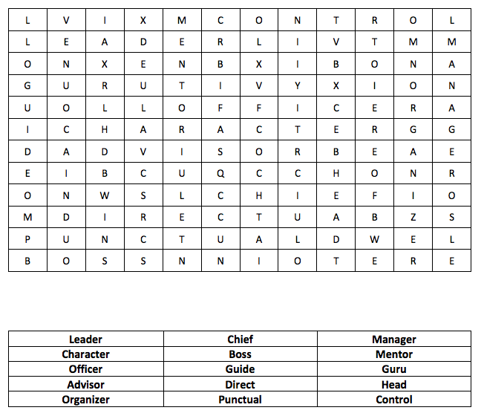

DIRECTIONS: Make as many words as you can from the word, “LEADERSHIP” below. You may use a letter more than once ONLY if it appears more than once.

