Lesson 3.01-Research-Details of a VBO

Virtual Business
Business Management & Administration

- In this lesson, we brainstormed a list of e-commerce sites and then evaluated them. Rate the websites listed below in order of importance (1=Most Important, 7=Least Important) as to what you think a website should include/be. Justify your thoughts in the space provided.

Does it use  Clipart,  GIFs, or  JPEGs? | If it has  images, do  they load  quickly? | Does it give the  name/contact  information of the  webmaster? | Does it have a  shopping  cart? | Does it allow  for online  payment? | Will it  accept  PayPal? | Is it easy to  understand and  navigate?

Student answers will vary. Grade based on completion and their justifications.

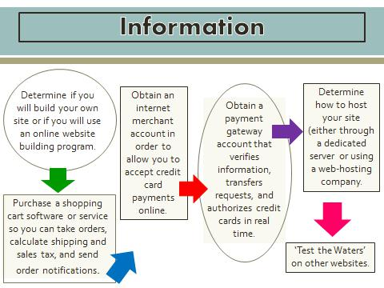
- In this lesson, we also covered the ‘behind-the-scenes’ steps that should be taken if you want to start an e-commerce business. Please list these steps (in order) or use a flow chart to report the information.

