Location
The location for my enterprise is

I chose this location because

COMPARISON OF COMPETITORS
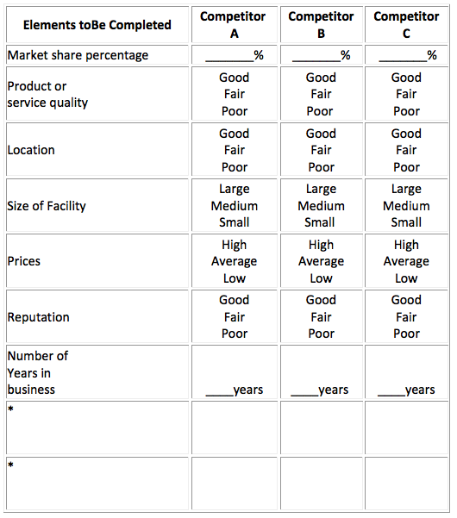

*Use these spaces for additional elements.

