Marketing to Generation X, Generation Y, Baby Boomers,
and the Silent Generation
Marketing to the Generations Rubric

Student Name: __________________________________

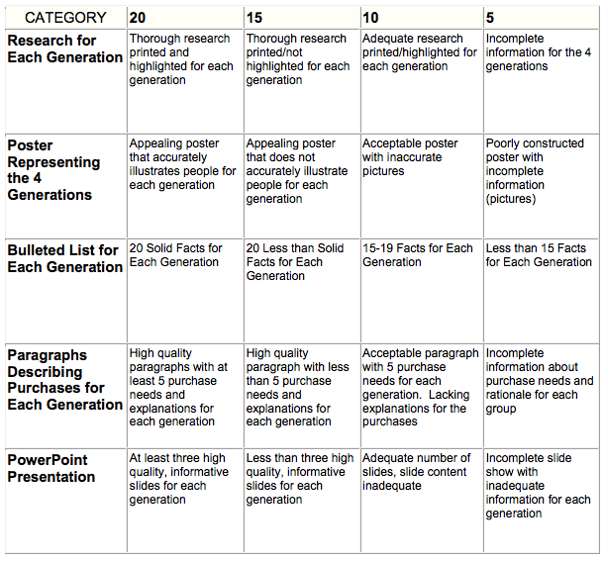

Total Score ____________
Maximum 100 Points

