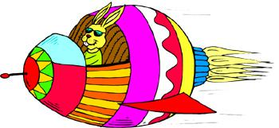
Mayday
Scenario:
Dr. Gabic and Uncle Sam were flying home to East Texas when their airplane started to stutter and then engine completely dies. They have no parachutes and they will have to jump to survive before the plane crashes. They have to build a parachute, glider, etc… some type of device that will slow their fall enough so that they survive. Dr. Gabic gets the plane leveled out and he and Uncle Sam get to work trying to save their lives.

Assignment:
You must build a device that Dr. Gabic and Uncle Sam can survive the jump from their airplane safely. You will be assigned by your teacher into groups of 1-2.

Criteria:
- Your team gets the following materials: You may use ONLY the following items.

1 - Round paper plate 2 - Drinking straws 1 - Cup 1 - 8 ½” x 11” white paper 12” - Clear tape 1 - Popsicle stick 2 pieces of 18” of string 6 -Toothpicks
1 light bulb or egg will represent Dr Gabic and Uncle Sam
Markers, Crayons, Map Pencils, etc. to decorate with *Tool: Only allowed to use scissors and yourself

*Design: Any design will be acceptable as long as it is functional and performs the assigned task safely.

- Assigned Task:
Build a device from only the materials provided to help Dr. Gabic and Uncle Sam survive the jump from their airplane. You must construct or incorporate into your device (for example part of the parachute or wings of a glider) a flag that shows your teams’ name and logo. It must be visible so that rescue teams can see it from the sky or ground. You get 1 minute to load your passengers. We will simulate the jump from off of the top of the football stadium.

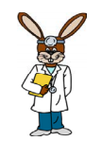
- Grading:
*Fastest descent and survival with no breakage or cracks = 100
*Survives with no breakage or cracks=90

*Survives but has some cracks = 80

*Breaks but does not shatter = 70

*Shatters = 60.

