Retailers in a Private Enterprise System
Name that Retailer Poster Assignment #2 Rubric

Student Name: _____________________________________________________

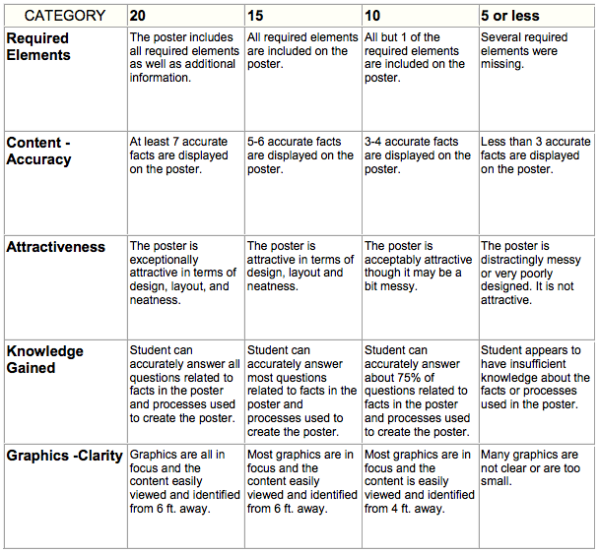

Total Score _______
Maximum 100 Points

