New Bank Research Assignment Rubric

Student Name: __________________________________

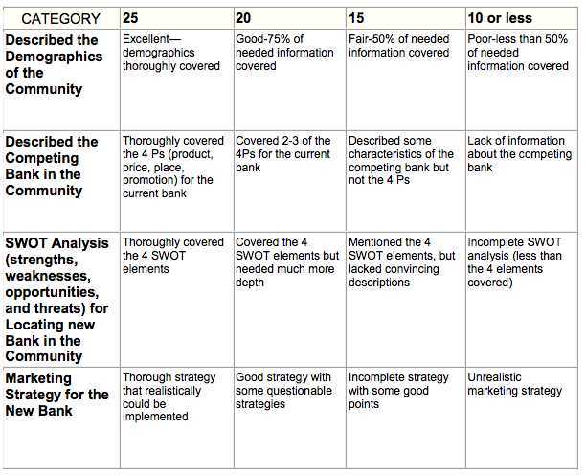

Total Score ____________
Maximum 100 Points

