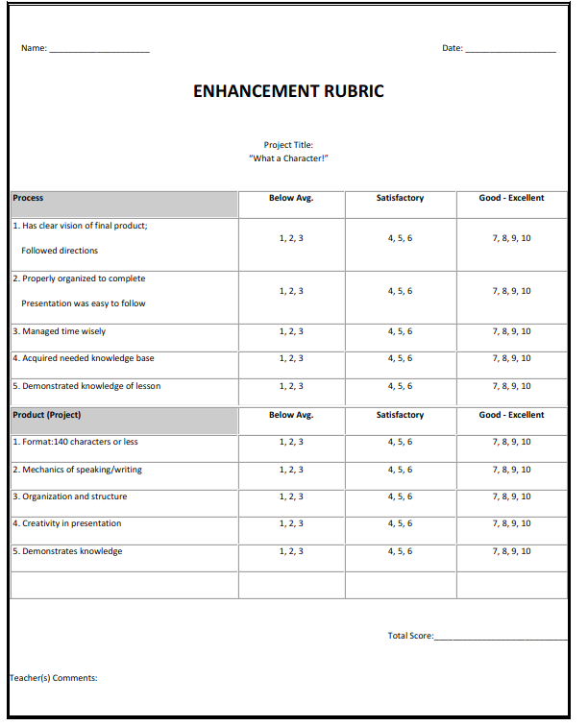 **Research Careers Using O\*NET**