Parallel Resistive Circuits Quiz

- How do you identify a parallel circuit?

A Only one path for current flow

B Multiple paths for current flow
C Multiple circuit voltages
D Multiple circuit resistances

- The voltage across each parallel resistor

  - Is equal to the ratio of the resistance
  - Is equal to the ratio of the currents
  - Is the same
  - Cannot be determined

- Kirchhoff’s current law states

A The ratio of current at a node is equal to the ratio of resistance

B The total current into a node equals the total resistance out of the junction C The ratio of the voltages equals the ratio of the resistances

D The sum of the currents into a node equals the sum of the currents out

- When additional resistors are connected in parallel, total resistance

A Increases
B Decreases
C Stays the same
D Cannot be determined

- A parallel circuit acts like a

A Current divider
B Voltage divider
C Resistance divider
D Voltage source

- When there is an open circuit in one parallel branch

A Voltage increases
B Voltage decreases

C Other branch currents stay the same
D Other branch currents decrease

- A parallel circuit has the following resistances: R1 = 390 Ω, R2 = 560 Ω, R3 = 820 Ω. Which resistor has the least current?

A R1
B R2
C R3

D They all have the same current

- A parallel circuit has the following currents: IT = 110 mA, I1 = 20 mA, I3 = 40mA, I2 = _____.
  - 20 mA

  - 40 mA

  - 50 mA

  - 60 mA

- Four resisters are connected in parallel. IT = 50 mA, I1 = 15 mA, I4 = 25 mA, and R2 = R3. What is the current through R3?

- The following resistors are connected in parallel. R1 = 1 kΩ, R2 = 2.2 kΩ, R3 = 4.7 kΩ. What is RT?

- The following resistors are connected in parallel. R1 = 3.3 kΩ, R2 = 4.7 kΩ, R3 = 6.8 kΩ. What is
RT?

12. In a parallel circuit, R1 = R2 = R3 and RT = 3.3 MΩ. What is R1?

13. In the following circuit, what is IT?
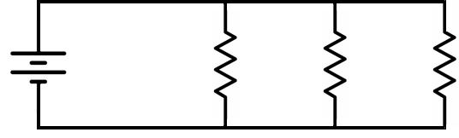
V_{S} | = | R₁ | = | R₂ = | R₃ =
15 V
 |  | 20 kΩ |  | 20 kΩ | 40 kΩ

14. In the following circuit, what is VS?
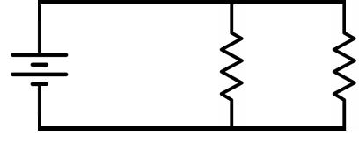
V_{S} = | I_{T} = 86 mA
 | R = | R =
? | 1 | 2
 | 1.5 kΩ | 300 Ω

21.5 V

15. In the following circuit, what is R1?
V_{S} = | I_{T} = 1.36 mA | R₂ =
 | R₁ =
20 V | ? Ω | 32.3 kΩ

  - KΩ

- In the following circuit, what is R2?
 | I_{T} = 6.18 mA
V = | R₂ = | R₂ =
S | 6.6 kΩ | ? kΩ
32 V

24 KΩ

