Pounds and Pounds of Pecans – Estimating Production

How can this problem be applied in an agricultural setting?

According to an article in Trees, Trees, Trees and More Trees, a grower can calculate the number of pounds of pecans produced by an acre of pecan trees using the formula

ƒ (t) = -2.5t² + 180t

where ƒ(t) is the number of pounds produced per acre; and t is the number of trees per acre. According to this formula, how many pounds of pecans can an acre produce from 30 producing trees per acre on the 100-acre Pecan Pie Farm?

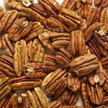

Answer: 3,150 pounds

Would planting more trees in an acre actually achieve a higher rate of production?

