Maslow’s Hierarchy of Needs

Objective: To compare Maslow’s concept of a self-actualized individual to a typical student’s view of a self-actualized individual

Procedure: Present the following situation to the class:
”This class is stranded on a deserted island. The island is in the northern Atlantic, and it is September. There are no other people or buildings on the island; however, there is vegetation.”

Divide the class into groups of three or four and have them answer the following questions.

- What are the first steps you would take to survive?

- What steps would you take to secure the class’ future?

Students should list the steps in order that they would take them. Review and discuss answers.
Suggested Responses:

- Design rules for protection of person and property

- Write rules for social interactions, such as marriage

- Provide for children’s education

- Provide tasks for adults

- Create outlets for entertainment and self-expression

- Determine rules for leadership

PART A
Below is an image of Maslow’s Hierarchy of Needs. According to Maslow, once one level is satisfied, then people try to satisfy the next level (working from the bottom to the top of the pyramid). He also believed that once a person fulfilled a level of need, that person was no longer motivated by that need.
Maslow defines self-actualization as developing and reaching one’s individual potential and being the best person one can be. Fill in the levels.
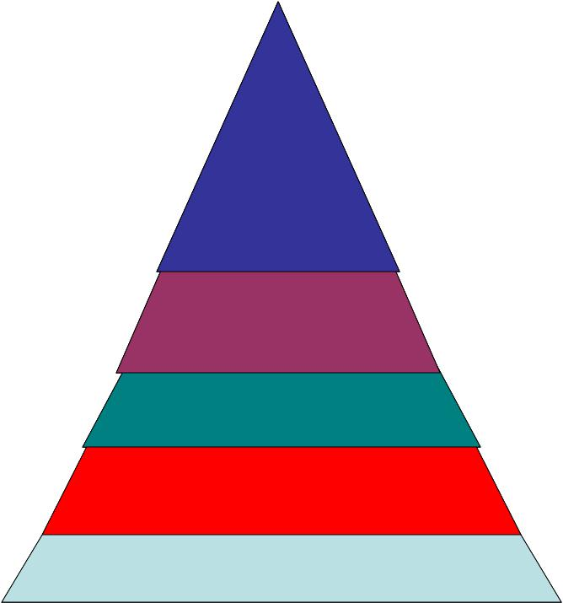

- Name a person who you believe has reached the level of self-actualization. It can be someone you know personally, someone famous, or someone from history.

- List the qualities of this person on the back.

