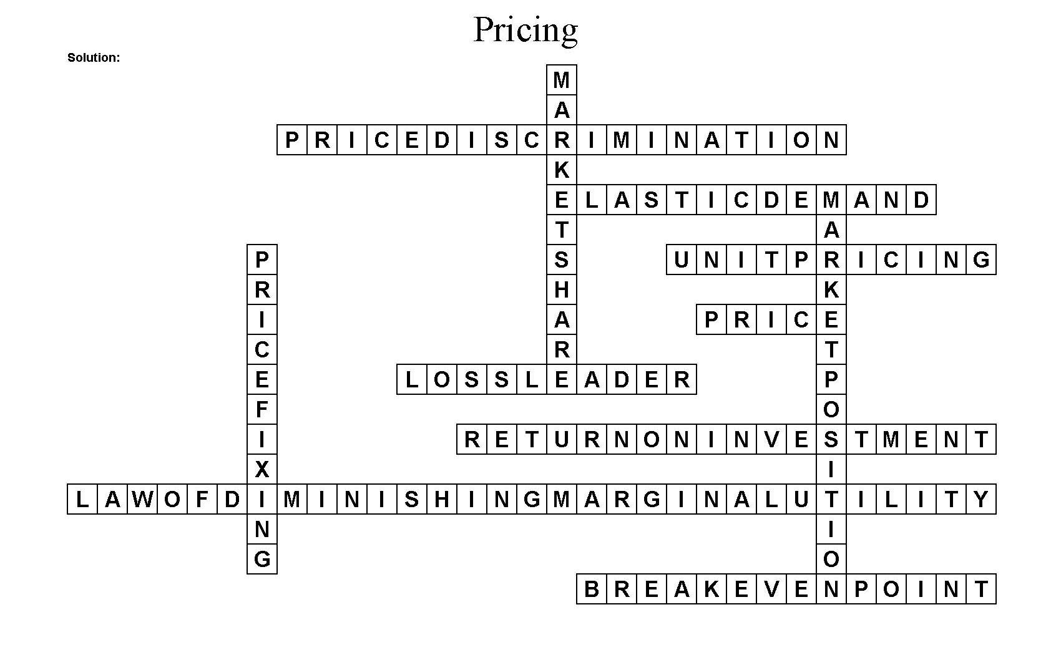
Independent Practice
Pricing Crossword Answer Key

