Producers in a Private Enterprise System
Shopping Mall Assignment PowerPoint Presentation Rubric

Student Name: _____________________________________________________

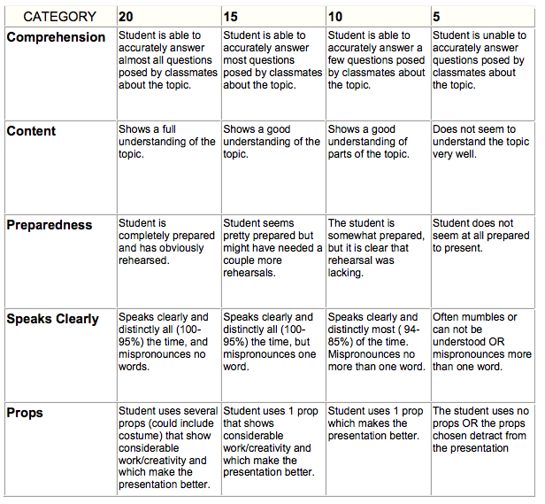

Total Score _______
Maximum 100 Points

