Trace Evidence: Hair Quiz Key
- B

- A

- C

- B

- C

- - Anagen – active growth phase (abundance of pigments, ribbon-like root). Often found with follicular tag.

  - Catagen – the intermediate growth phase (elongated root shape).

  - Telogen – resting phase (bulb-like root shape with fewer pigments). Often found with abundance of cortical fusi.

7)
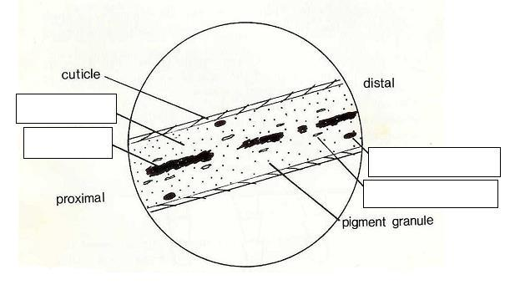

cortex

medulla

ovoid body

cortical fusi

