Name________________________________ Date__________________________

Rescue Equipment Worksheet

Directions: Name the following pieces of rescue equipment and give one use for each. (Many of these tools have multiple uses, but listing one is sufficient.)

- Tool: ____________________________________________________________

- Use: _____________________________________________________________
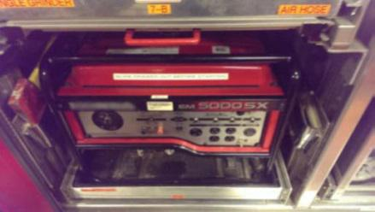

- Tool: ____________________________________________________________

- Use: _____________________________________________________________
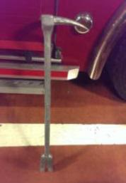

- Tool: _______________________________________________________________

- Use: _______________________________________________________________
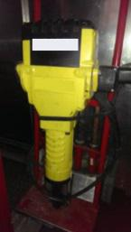

- Tool: _______________________________________________________________

- Use: _______________________________________________________________
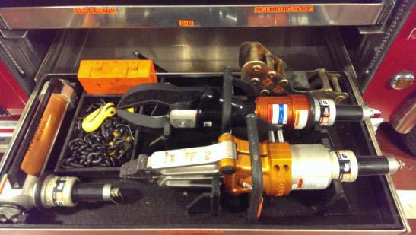

- Tool: _______________________________________________________________

- Use: _______________________________________________________________
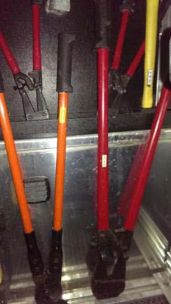

- Tool: _______________________________________________________________

- Use: _______________________________________________________________
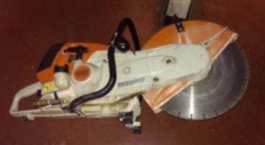

- Tool: _______________________________________________________________

- Use: _______________________________________________________________

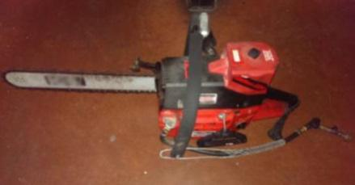

- Tool: _______________________________________________________________

- Use: _______________________________________________________________
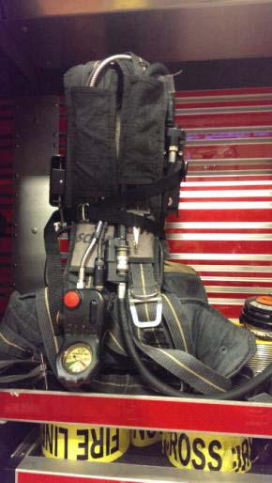

- Tool: _______________________________________________________________

- Use: _______________________________________________________________

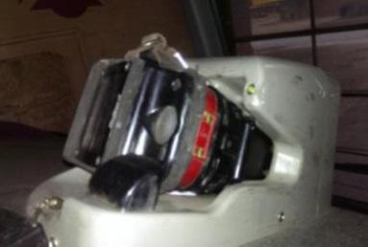

- Tool: _______________________________________________________________

- Use: _______________________________________________________________
