Name________________________________ Date__________________________

Rescue Quiz

- _____When is it acceptable to go into a structure fire in a “rescue capacity”?

  - When it is a home full of valuables in excess of 1 million dollars

  - When there are dogs heard barking inside the home

  - When there are known occupants to be inside

  - When there is a possibility of occupants inside

- _____Finish this sentence: “Extend limited risk only if…”

  - Property or lives are savable.

  - Property and contents are savable.

  - Lives and pets are savable.

  - Lives, pets, property, and valuables are savable.

- _____There are situations when it is okay to risk firefighter lives for vacant property.

  - True
  - False

- _____What is a clue that a house is occupied?

  - The electric meter is missing

  - There is high grass in the yard

  - The porch light is on at the residence

  - Multiple newspapers are in the yard

- _____Where should a search and rescue start?

  - Closest to the entryway

  - In the area of greatest chance for occupant survival

  - In the area of greatest risk

  - In the northernmost point of the house, in a counter clockwise rotation

- _____What are the two types of searches?

  - First/Second

  - Initial/Secondary

  - Rescue/Recovery

  - Primary/Secondary

- _____Which is not a rescue technique?

  - Assist

  - Drag

  - Haul

  - Carry

- _____When should you consider a “shelter in place” option?

  - When the exit is over 100 feet away

  - When the occupants are in greater danger by trying to exit

  - When the weather is inclement outside

  - When the fire is over 50 feet from your location

- _____Which is not one of the four simple carries?

  - Two-person extremity carry

  - Two-person seat carry

  - Two-person cradle carry

  - Two-person chair carry

- _____What NFPA Standard deals with driving and riding in a fire department apparatus?

  - 5100

  - 1500

  - 1515

  - 1550

- _____At what oxygen level are you required to use an SCBA per NFPA requirements?

  - 23%

  - 21%

  - 19%

  - 17%

- _____What is the following tool?
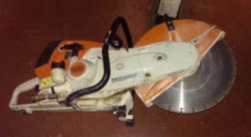

  - Circular Saw

  - Disk Saw

  - K12 Saw

  - Recipro Multi-Function Saw

- _____What materials will the above tool cut?

  - Wood

  - Concrete

  - Metal

  - All of the above

- _____What is the following?
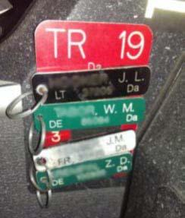

  - Identification Velcro Device (IVD)

  - Personnel Location Plaque (PLP)

  - Personnel Accountability Tags (PAT)

  - None of the above

- _____There is never a reason to violate the “two in, two out” procedure.

  - True
  - False

- _____Toys in the yard and cars in the driveway are signs a structure is occupied.

  - True
  - False
- _____Firefighters need to check out a SCBA once a week per NFPA requirements.

  - True
  - False

- _____Secondary searches should be done by the same company that did primary searches.

  - True
  - False

- _____Personal Protective Equipment (PPE) is not required during a search if the fire is out.

  - True
  - False

- _____A Personal Alert Safety System (PASS) device is used to locate heat sources and fire spread.

  - True
  - False

