Resistance Value and Tolerance Range Answer KEY

Determine the resistance value and tolerance range of the following resistors.

 | 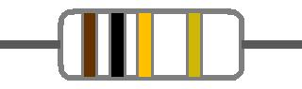 | A.) Indicated Resistance: 100000Ω  B.) Tolerance: 5000  C.) Acceptable Resistance Value Range: 95000 – 105000 Ω
A.) Indicated Resistance: 720000 Ω
B.) Tolerance: 36000
C.) Acceptable Resistance Value Range: 684,000 – 756,000 Ω
 | 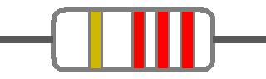 | A.) Indicated Resistance: 2200 Ω  B.) Tolerance: 110 Ω  C.) Acceptable Resistance Value Range: 2090 – 2310 Ω
A.) Indicated Resistance: 65 Ω
B.) Tolerance: 3.25
C.) Acceptable Resistance Value Range: 61.75 – 68.25 Ω
A.) Indicated Resistance: 4 Ω
B.) Tolerance: .2
C.) Acceptable Resistance Value Range: 3.8 – 4.2 Ω
 | 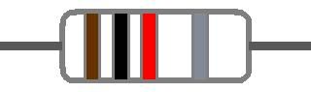 | A.) Indicated Resistance: 1000 Ω  B.) Tolerance: 100  C.) Acceptable Resistance Value Range: 900 – 1100 Ω
A.) Indicated Resistance: 8000
B.) Tolerance: 400
C.) Acceptable Resistance Value Range: 7600 – 8400 Ω
A.) Indicated Resistance: 1800000 Ω
B.) Tolerance: 90,000
C.) Acceptable Resistance Value Range: 1710000 – 1891000 Ω
A.) Indicated Resistance: 570 Ω
B.) Tolerance: 28.5
C.) Acceptable Resistance Value Range: 541.5 – 598.5 Ω
A.) Indicated Resistance: 200000 Ω
B.) Tolerance: 10,000
C.) Acceptable Resistance Value Range: 190,000 – 210,000 Ω

- How would you tell a 1 W resistor from a ½ W Resistor?

- The color code is different
- The 4th band is silver
- The physical size is different
- The leads are different length

- Which of the following is the formula for heat dissipation?

