Name ____________________________________________Date __________________Class ______

Resistance Value and Tolerance Range

Determine the resistance value and tolerance range of the following resistors.

 | 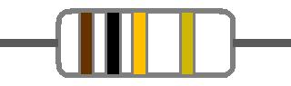 | A.) Indicated Resistance:  B.) Tolerance:  C.) Acceptable Resistance Value Range:
A.) Indicated Resistance:
B.) Tolerance:
C.) Acceptable Resistance Value Range:
 | 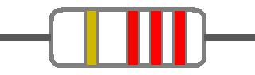 | A.) Indicated Resistance:  B.) Tolerance:  C.) Acceptable Resistance Value Range:
A.) Indicated Resistance:
B.) Tolerance:
C.) Acceptable Resistance Value Range:
A.) Indicated Resistance:
B.) Tolerance:
C.) Acceptable Resistance Value Range:
 | 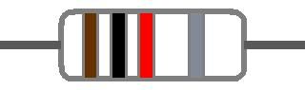 | A.) Indicated Resistance:  B.) Tolerance:  C.) Acceptable Resistance Value Range:
 | 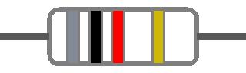 | A.) Indicated Resistance:  B.) Tolerance:  C.) Acceptable Resistance Value Range:
 | 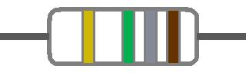 | A.) Indicated Resistance:  B.) Tolerance:  C.) Acceptable Resistance Value Range:
 | 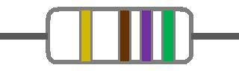 | A.) Indicated Resistance:  B.) Tolerance:  C.) Acceptable Resistance Value Range:
A.) Indicated Resistance:
B.) Tolerance:
C.) Acceptable Resistance Value Range:

- How would you tell a 1 W resistor from a ½ W Resistor?

- The color code is different
- The 4th band is silver
- The physical size is different
- The leads are different length

- Which of the following is the formula for heat dissipation?

