Resistors Color Code

1st Color Band: First digit of value
2nd Color Band: Second digit of value

Tolerance

3rd Color Band: Multiplier or numbers of zeros

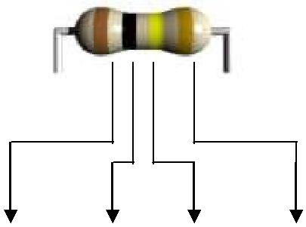
Example:

Brown  1 | Black  0 | Yellow  0000 | Gold  5%

 | Significant Digit | Decimal Multiplier
 | First and second band | Third band
Black | 0 | 1
Brown | 1 | 10
Red | 2 | 100
Orange | 3 | 1,000 (k)
Yellow | 4 | 10,000
Green | 5 | 100,000
Blue | 6 | 1,000,000 (M)
Violet | 7 | 10,000,000
Gray | 8 | 100,000,000
White | 9 | 1,000,000,000

