Retailers in a Private Enterprise System
Retail Interview PowerPoint Assignment #3 Rubric

Student Name: _____________________________________________________

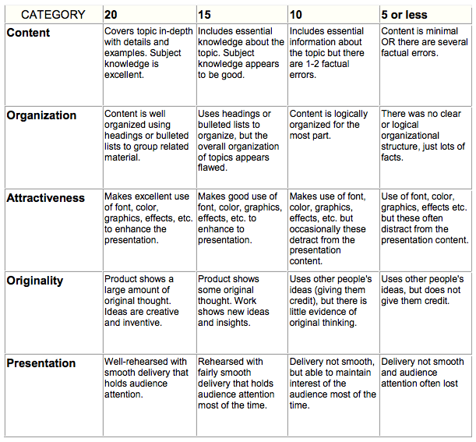

Total Score _______
Maximum 100 Points

