Retailers in a Private Enterprise System
Retailer Loyalty Assignment Research Paper Assignment #1 Rubric

Student Name: _____________________________________________________
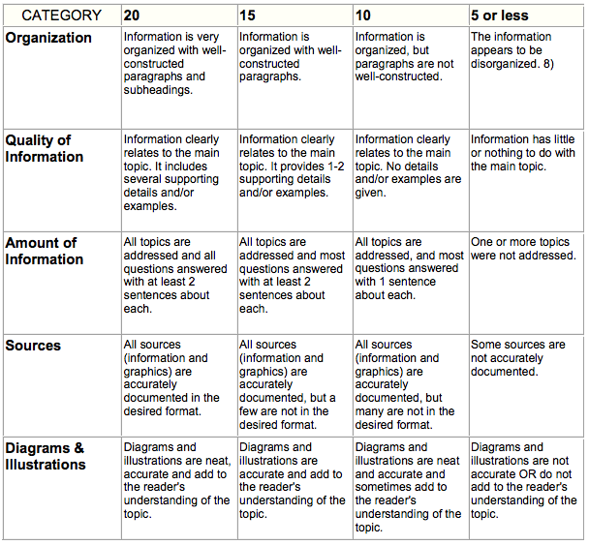

Total Score _______
Maximum 100 Points

