Draw a Robot Model
Part I. Proportion Problems Exercise

Directions

Calculate the proportion problem listed below before you draw a model of your robot. A proportion involves ratios. A proportion is a statement showing that two ratios are equal. If two ratios are equal, their cross products are equal. For example, “a is to b” as “c is to d” used to calculate a proportion and the scale measurements.

a : b : : c : d, a/b = c/d, b ≠ 0, d ≠ 0

- 2 in = 1 ft

Use the ratio to write a proportion. Cross multiply to solve.

2 in = |  | X in
1 ft |  | 2 ft

2. 1.5 in = 1 ft

Use the ratio to write a proportion. Cross multiply to solve.

1.5 in | = X in
1 ft | 1.5 ft

- 2.5 in = 1 ft

Use the ratio to write a proportion. Cross multiply to solve.

2.5 in | = X in
1 ft | 2.5 ft
Part II. Draw Robot Model
Directions

Draw a model of your robot. Make a new drawn-to-scale drawing of your robot using rulers and the scale measurements from your calculations. (Refer to the drawings below.) Pick a ratio to convert the life-size measurements to the drawn-to-scale measurements. For example, one foot equals one inch. The ratio will then be used to write a proportion to find the scale measurements.

Example 1: Drawing of the Wheels, Bed, and Arm
- Wood wheels with a rubber coating
- Plastic bed at a 45 degree angle
- Robot arm with a hook at the end
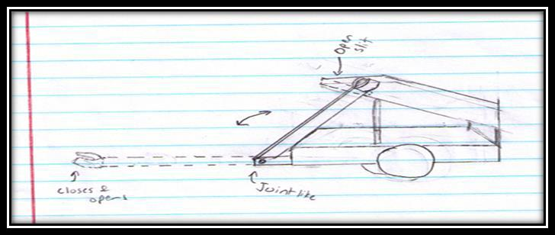

Drawing from the Nimitz High School Robotics Team

Example 2: Drawing of the Robot Arm

- Joint-like bend allows arm to move from the floor to the open slit in the bed, allowing the arm to grip and drop-off items

- Hook at the end opens and closes, allowing it to grip the items

- Both movements (the bend of the arm and the grip of hook) are powered by servos
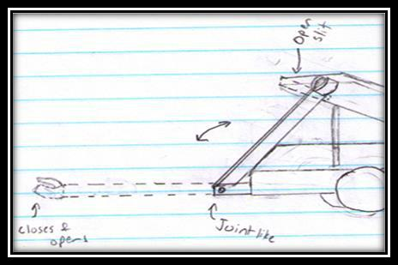

Drawing from the Nimitz High School Robotics Team
Example 3: Drawing of the Base/Bed
- Angled at 45 degrees
- Made of plastic
- Has an open slit, allowing the arm to drop off items
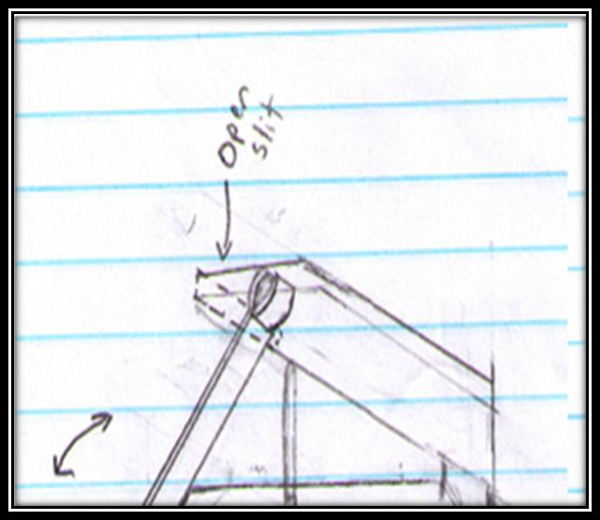

Drawing from the Nimitz High School Robotics Team

Example 4: Drawing of the Wheels
- Wooden wheels covered with the rubber material to increase traction
- Wheels powered by separate motors
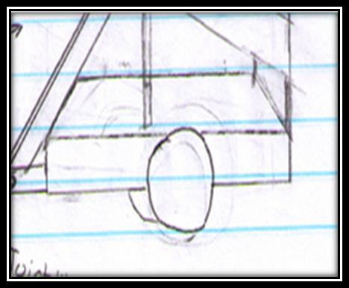

Drawing from the Nimitz High School Robotics Team

