Name:____________________________________ Date:_____________________________

Role Play Rubric

 |  | Objectives |  | 4 pts. | 3 pts. | 2 pts. Needs Some |  | 1 pt. Needs Much |  |  | N/A |  |  | Pts.
 |  |  |  | Excellent | Good | Improvement |  | Improvement
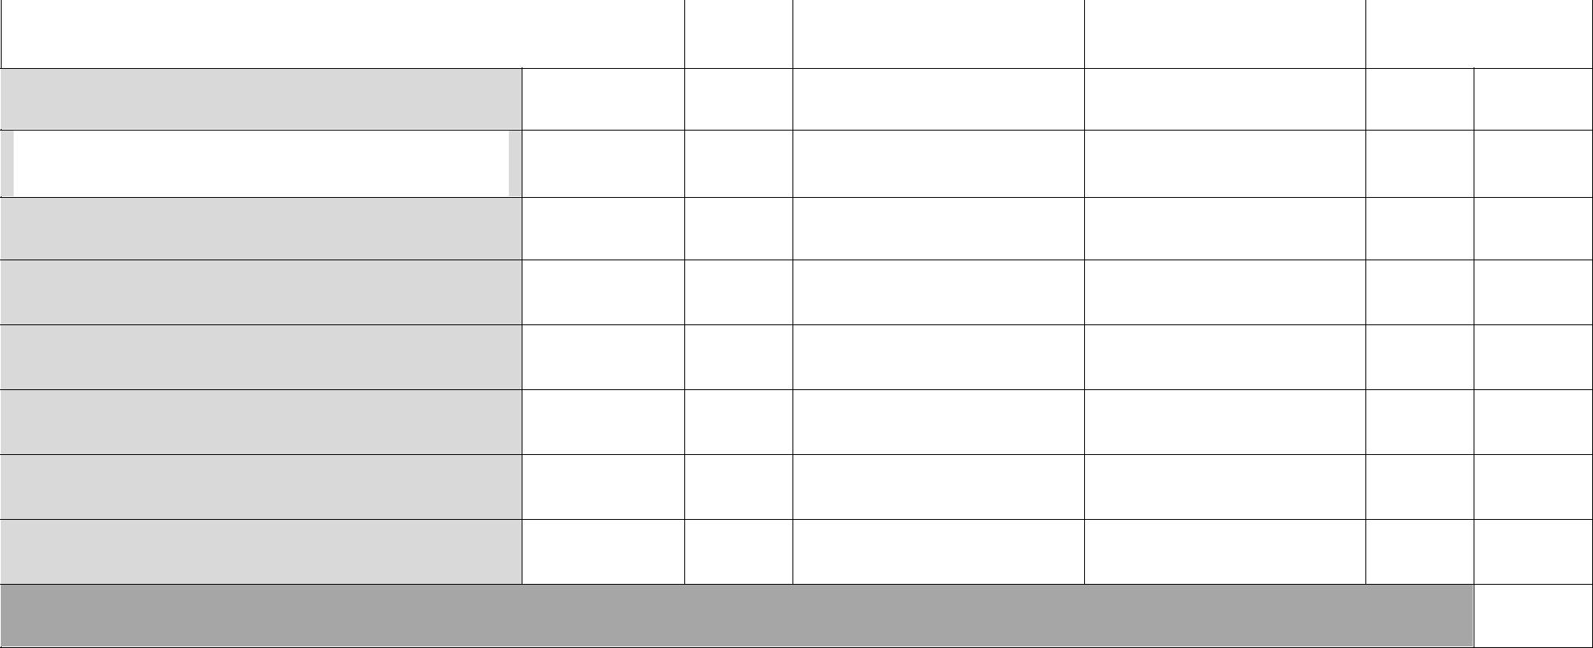

Relates to the audience

Provides fluent rendition of the
scenario

All required content is included

Acts with feeling and expression

Varies intonation

Presents characters appropriately

Gives the scenario its full range

Breaches are easily identified

Total Points (32 pts.)

Comments:

