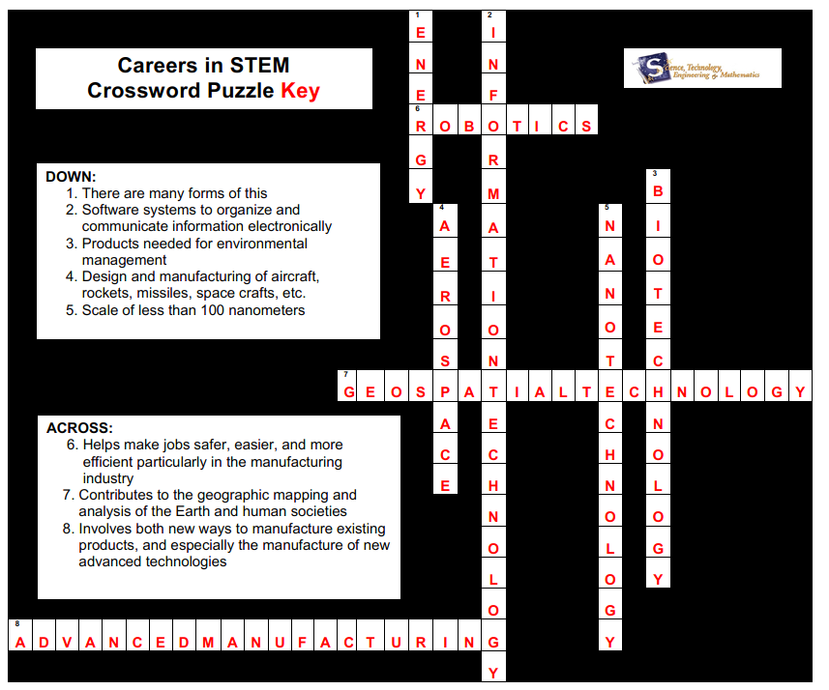
CAREER EXPLORATION – CREATING A CROSSWORD PUZZLE KEY AND GRADING KEY
