Sail Boat

Scenario:

Dr Gabic and Uncle Sam were going on a hunting trip, but their airplane crashed. Refer to the “Happy Birthday Boy” writing prompt story. Uncle Sam is hurt and Dr Gabic has to get him across Lake Conroe to get him medical help.

Assignment:

Build a sail boat from the crashed “airplane” parts. It must be able to fit into the Air Pressure Test Chamber, which is 8” Tall, 8” Wide, and 20” Long!
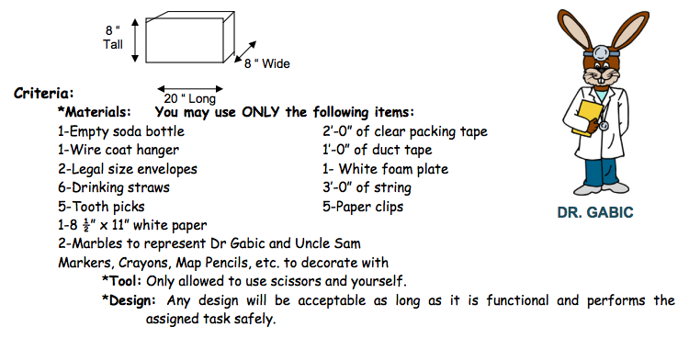

- Assigned Task:
Build a sail boat that can transport Dr Gabic and Uncle Sam across the treacherous lake Conroe, after the crash of the airplane from “Happy Birthday Boy.” They can get wet, but at no time can they be submerged or completely under water.

- Grading:
- Points - Wind Tunnel Test: 20 lb PSI is the MINIMUM! You will receive extra points for every PSI it survives over the minimum up to 40 PSI. So possible is 50 points.
- Points – Fastest Time Across the Lake: Team with fastest time gets the 30 points, 2nd 29 points, etc.

- Points - Most Creative: The other classes will come in and judge this category, 1st is 30 points, 2nd 29, etc. (Judged before we test the structure.)

- Points - Team Work: Given by your team as a whole to each member individually.
- Points - Team Work: Given by the teacher.

