Sample Box Print Views Handout
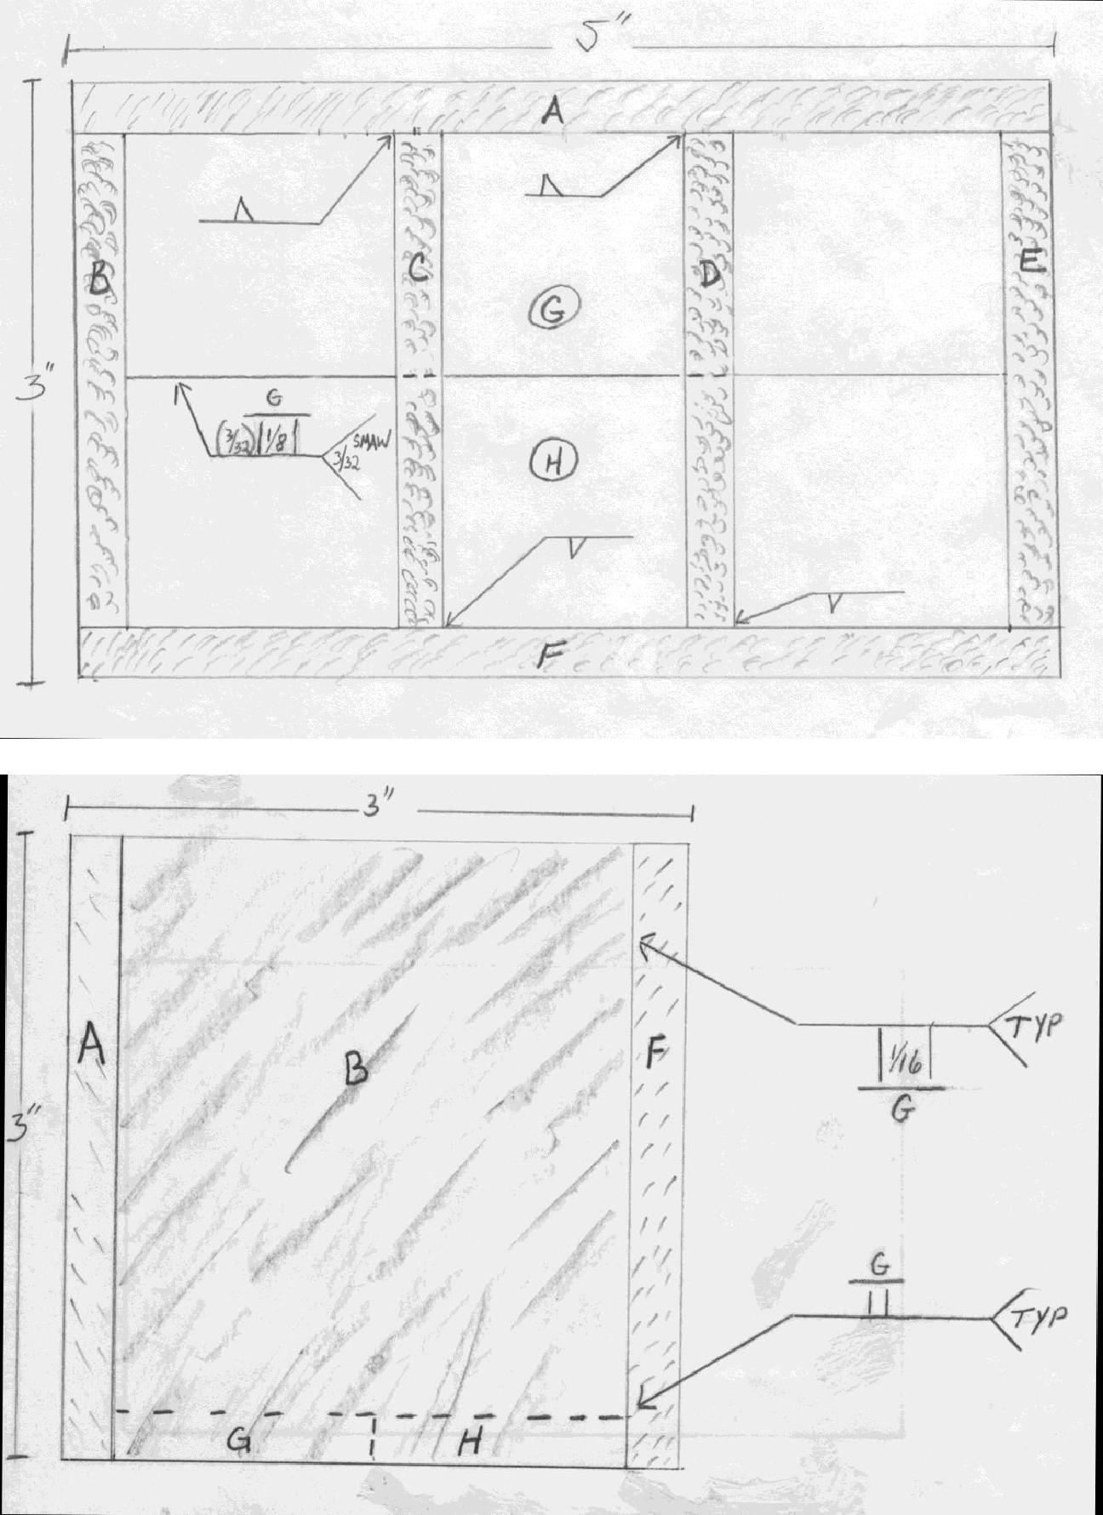

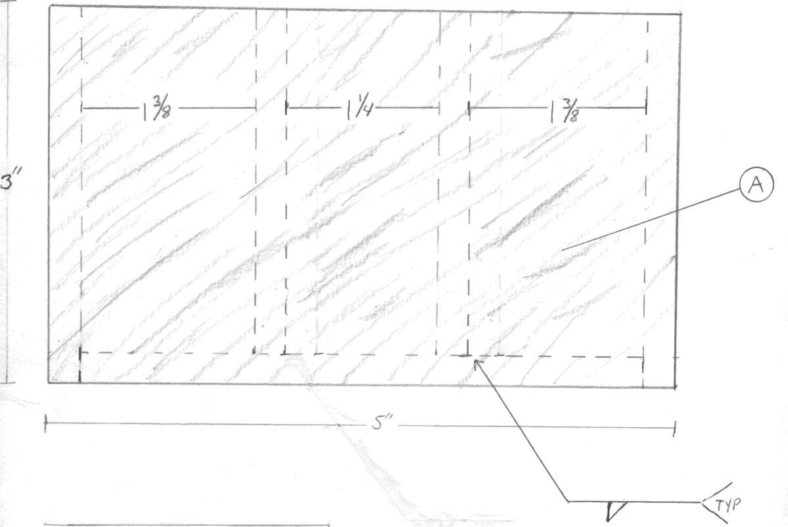

Student Signature_________________________________________________________

Peer Signature ___________________________________________________________

Teacher Signature ________________________________________________________

PARTS TEMPLATE
Section | Size |  | Description
A, F | 5 x 3 |  | Sides
B, E | 2 | ½ x 3 | Ends
C, D | 2 | ½ x 2 ¾ | Inside dividers
G, H | 4 | ½ x 1- 3/16 | Bottom

