Name_______________________________________Date_________________________Class____________

Sample Problems With Three Resistors

Worksheet
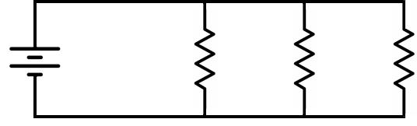
V_{S} | R₁ | R₂ | ^{R}3

1. | VS = 8 V, R1 = 200 Ω, R2 = 400 Ω R3 = 400 Ω, Solve for RT and IT | ____________________________________________
2. | VS = 15 V, R1 = 330 Ω, R2 = 470 Ω R3 = 250 Ω, Solve for RT and IT | ____________________________________________
- VS = 15 V, R1 = 2.7 kΩ, R2 = 4.5 kΩ, R3 = 6.2 kΩ, Solve for RT and IT ___________________________________________________________
4. | VS = 9 V, R1 = 15 kΩ, R2 = 8.6 kΩ, R3 = 6 kΩ, Solve for RT and IT | ____________________________________________
5. | IT = 25 mA, R1 = 4 kΩ, R2 = 4 kΩ, R3 = 2 kΩ, Solve for Vs | ____________________________________________
6. | IT = 8 mA, R1 = 1.2 kΩ, R2 = 3.75 kΩ, R3 = 2 kΩ, Solve for Vs | ___________________________________________
- IT = 20 mA, R1 = 1.5 kΩ, R2 = 3 kΩ, R3 = 2 kΩ, Solve for I1, I2, and I3 ____________________________________________
8. | IT = 15 mA, R1 = 4 kΩ, R2 = 12 kΩ, R3 = 6 kΩ, Solve for I1, I2, and I3 | ____________________________________________
9. | VS = 20 V, IT = 100 mA, I2 = 20 mA, I2 = 30 mA, Solve for R1 | ____________________________
10. | VS = 35 V, IT = 20 mA, I2 = 10.89 mA, I3 = 5.93 mA, Solve for R1 | ____________________________
11. | VS = 18 V, IT = 6.2 mA, R1 = 15 kΩ, R3 = 9 kΩ, Solve for R2 | ____________________________
12. | VS = 10 V, IT = 69.5 mA, R1 = 330 Ω, R3 = 560 Ω, Solve for R2 | ____________________________
13. | IT = 11.1 mA, R1 = 14.4 kΩ, I1 = 2.5 mA, R3 = 10 kΩ, Solve for R2 | ____________________________
14. | V1 = 9 V, R1 = 3 kΩ, I2 = 2.5 mA, I3 = 3.6 mA, Solve for R2 and R3 | ___________________________________________

