Name_______________________________________Date_________________________
Sample Problems With Two Resistors Worksheet
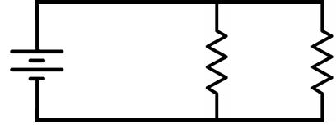
^{V}S |  | ^{R}1 | ^{R}2

- VS = 24 V, R1 = 10.56 kΩ, R2 = 8.8 kΩ, Solve for RT and IT __________________________________________________
2. | VS = 14 V, R1 = 9.6 kΩ, R2 = 8.4 kΩ, Solve for RT and IT | ___________________________________________________
3. | IT = 25 mA, R1 = 2 kΩ, R2 = 3 kΩ, Solve for Vs | ___________________________________________________
4. | IT = 2.25 mA, R1 = 20 kΩ, R2 = 80 kΩ, Solve for Vs | ___________________________________________________
5. | IT = 75 mA, R1 = 390 Ω, R2 = 624 Ω, Solve for I1 and I2 | ___________________________________________________
6. | IT = 3.25 mA, R1 = 2.4 kΩ, R2 = 8 kΩ, Solve for I1 and I2 | __________________________________________________
7. | VS = 20 V, IT = 100 mA, I2 = 20 mA, Solve for R1 | ___________________________________________________
8. | VS = 12 V, IT = 4.1 mA, I1 = 2.5 mA, Solve for R2 | __________________________________________________
9. | VS = 18 V, IT = 92.8 mA, I2 = 54.54 mA, Solve for R1 | _________________________
10. | VS = 6 V, IT = 20 mA, R2 = 1.2 kΩ, Solve for R1 | _________________________________
11. | VS = 9 V, IT = 3.33 mA, R2 = 4.2 kΩ, Solve for R1 | _________________________________
12. | VS = 16 V, IT = 70.6 mA, R1 = 340 Ω, Solve for R2 | _________________________
13. | R1 = 16 kΩ, I1 = 1.75 mA, I2 = 1.25 mA, Solve for R2 | _________________________________
- IT = 27 mA, VS = 54 V, R1 = R, R2 = 2R, Solve for R1 and R2 __________________________________________________

